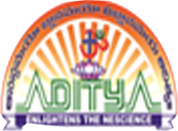
ADITYA DEGREE COLLEGES
ANDHRA PRADESH

MID – 1 SYLLABUS
SOFT SKILLS
SEMESTER – I
UNIT – 1 :
1. VOCABULARY BUILDING
UNIT – 2 :
1. GRAMMAR – 1

SEMESTER – III
UNIT – 1 :
1. PRONUNCIATION -1
UNIT-2:
1. PRONUNCIATION-2
UNIT-3:
- SPEAKING SKILLS – 1
- Conversation skills
- Interview skills

